**Uber**

**Dashboard Analytics Project**

**Title:** Uber Dashboard Analytics Project  
**Name:** [Hajira Banu.k]  
**Date:** [8/12/2024]

**Table of Contents**

1. Introduction
2. Tools & Technologies Used
3. Dashboard Overview
4. Data Preparation
5. Key Insights
6. Challenges & Solutions
7. Conclusion
8. Future Scope
9. Appendix

**1. Introduction**

**Objective:** The purpose of this project is to provide key insights into Uber operations, including customer bookings, ratings, and cancellations, through a visually intuitive dashboard.  
**Motivation:** This project was under taken to demonstrate data visualization skills and provide actionable insights that Uber can use to improve customer experience and operational efficiency.

**2. Tools & Technologies Used**

* **Data Cleaning:** Google Sheets, MySQL workbench
* **Visualization:** Power BI
* **Dataset Source:** [ Kaggle]

**3. Dashboard Overview**

he dashboard includes the following key metrics:

1. **Number of Bookings:** Total customer bookings visualized using bar charts.
2. **Ratings Given:** Count of customers who provided ratings, shown as a pie chart or histogram.
3. **Cancellations:** Number of cancellations displayed through a line chart showing trends over time.
4. **Ride Volume Over Time**
5. **Booking Status Breakdown**
6. **Top 5 Vehicle Types by Ride Distance**
7. **Average Customer Ratings by Vehicle Type**
8. **Cancelled Rides Reasons**
9. **Revenue by Payment Method**
10. **Top 5 Customers by Total Booking Value**
11. **Ride Distance Distribution Per Day**
12. **Driver Ratings Distribution**
13. **Customer vs. Driver Ratings**

**Visual Examples:**

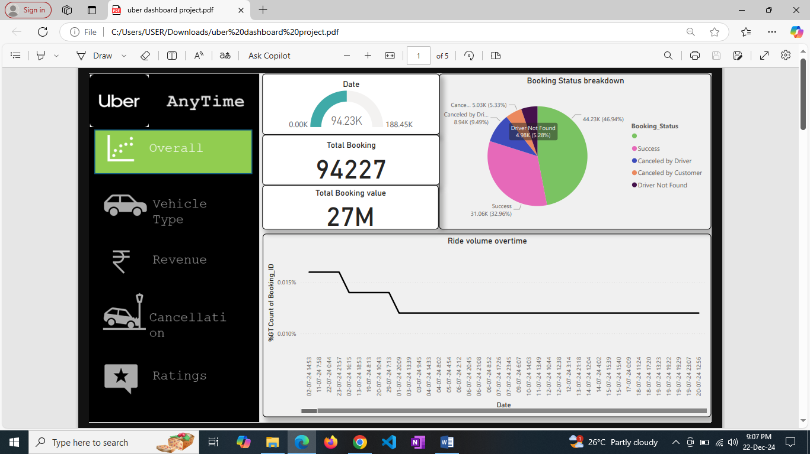

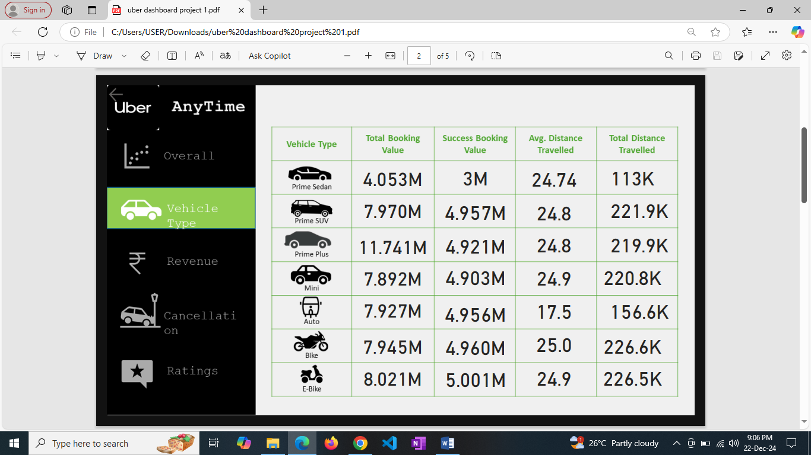

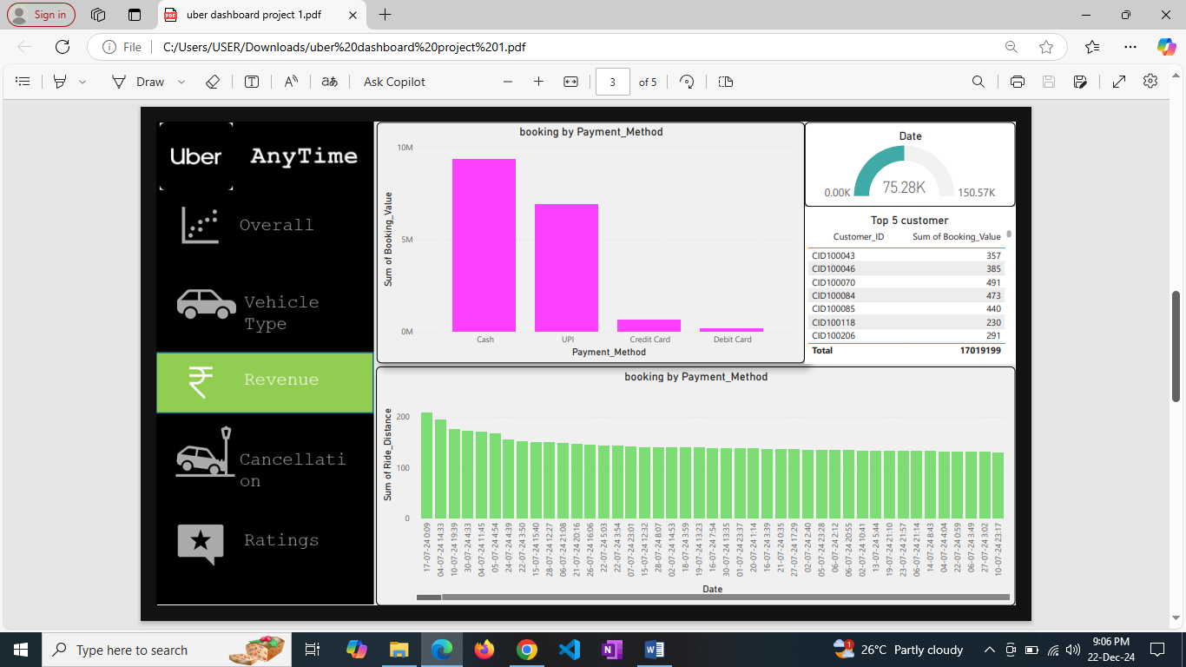

**4. Data Preparation**

* **Dataset Cleaning:** Removed duplicate entries and handled missing values.
* **Calculated Metrics:** Created fields for total bookings, average ratings, and cancellation percentages.
* **Data Transformation:** Aggregated data by date and time for trend analysis.

**5. Key Insights**

1. Bookings peak during weekends and holidays.
2. The average customer rating is consistently above 4.0, indicating positive feedback.
3. Cancellation rates are highest during peak traffic hours (e.g., mornings and evenings).
4. Customers prefer certain vehicle types for longer ride distances.
5. Payment methods like digital wallets contribute significantly to revenue.
6. Most cancellations are due to driver delays or customer change of plans

**6. Challenges & Solutions**

* **Challenge:** Handling incomplete data entries. **Solution:** Imputed missing values using averages or median values.
* **Challenge:** Visual clutter in initial dashboards. **Solution:** Simplified layouts and used consistent color schemes.

**7. Conclusion**

This dashboard successfully identifies key patterns in Uber bookings, ratings, and cancellations. These insights can help Uber optimize resource allocation and enhance customer satisfaction.

**8. Future Scope**

1. Incorporating customer segmentation to analyze behavior.
2. Adding predictive analysis for demand forecasting.
3. Visualizing geographical trends in bookings and cancellations.

**9. Appendix**

* **Links to Project Files:** [GitHub]
* Dashboard: uber dashboard project.pdf

**Contact Information**

[Email:hajihaju19@gmail.com]  
[LinkedIn: www.linkedin.com/in/hajirabanu19]  
[ GitHub: https://github.com/hajihaju]